Mastering BERT: A Comprehensive Guide from Beginner to Advance in Natural Language Processing (NLP)
Introduction:
BERT (Bidirectional Encoder Representations from Transformers) is a revolutionary natural language processing (NLP) model developed by Google. It has transformed the landscape of language understanding tasks, enabling machines to comprehend context and nuances in language.
Table of Contents
- Introduction to BERT
- What is BERT?
- Why is BERT Important?
- How does BERT work?
2. Preprocessing Text for BERT
- Tokenization
- Input Formatting
- Masked Language Model (MLM) Objective
3. Fine-Tuning BERT for Specific Tasks
- BERT’s Architecture Variations (BERT-base, BERT-large, etc.)
- Transfer Learning in NLP
- Downstream Tasks and Fine-Tuning
- Example: Text Classification with BERT
4. BERT’s Attention Mechanism
- Self-Attention
- Multi-Head Attention
- Attention in BERT
- Visualization of Attention Weights
5. BERT’s Training Process
- Pretraining Phase
- Masked Language Model (MLM) Objective
- Next Sentence Prediction (NSP) Objective
6. BERT Embeddings
- Word Embeddings vs. Contextual Word Embeddings
- WordPiece Tokenization
- Positional Encodings
7. BERT’s Advanced Techniques
- Fine-Tuning Strategies
- Handling Out-of-Vocabulary (OOV) Words
- Domain Adaptation with BERT
- Knowledge Distillation from BERT
8. Recent Developments and Variants
- RoBERTa (A Stronger Baseline)
- ALBERT (A Lite BERT)
- DistilBERT (Compact Version)
- ELECTRA (Efficiently Learning an Encoder)
9. BERT for Sequence-to-Sequence Tasks
- BERT for Text Summarization
- BERT for Language Translation
- BERT for Conversational AI
10. Common Challenges and Mitigations
- BERT’s Computational Demands
- Addressing Long Sequences
- Overcoming Biases in BERT
11. Future Directions in NLP with BERT
- OpenAI’s GPT Models
- BERT’s Role in Pretrained Language Models
- Ethical Considerations in BERT Applications
12. Implementing BERT with Hugging Face Transformers Library
- Installing Transformers
- Loading Pretrained BERT Models
- Tokenization and Input Formatting
- Fine-Tuning BERT for Custom Tasks
Chapter 1: Introduction to BERT
What is BERT?
In the ever-evolving realm of Natural Language Processing (NLP), a groundbreaking innovation named BERT has emerged as a game-changer. BERT, which stands for Bidirectional Encoder Representations from Transformers, is not just another acronym in the vast sea of machine learning jargon. It represents a shift in how machines comprehend language, enabling them to understand the intricate nuances and contextual dependencies that make human communication rich and meaningful.
Why is BERT Important?
Imagine a sentence: “She plays the violin beautifully.” Traditional language models would process this sentence from left to right, missing the crucial fact that the identity of the instrument (“violin”) impacts the interpretation of the entire sentence. BERT, however, understands that the context-driven relationship between words plays a pivotal role in deriving meaning. It captures the essence of bidirectionality, allowing it to consider the complete context surrounding each word, revolutionizing the accuracy and depth of language understanding.
How does BERT work?
At its core, BERT is powered by a powerful neural network architecture known as Transformers. This architecture incorporates a mechanism called self-attention, allowing BERT to weigh the significance of each word based on its context, both preceding and succeeding. This context-awareness imbues BERT with the ability to generate contextualized word embeddings, which are representations of words considering their meanings within sentences. It’s akin to BERT reading and re-reading the sentence to gain a deep understanding of every word’s role.
Consider the sentence: “The ‘lead’ singer will ‘lead’ the band.” Traditional models might struggle with the ambiguity of the word “lead.” BERT, however, effortlessly distinguishes that the first “lead” is a noun, while the second is a verb, showcasing its prowess in disambiguating language constructs.
In the chapters to come, we will embark on a journey that demystifies BERT, taking you from its foundational concepts to its advanced applications. You’ll explore how BERT is harnessed for various NLP tasks, learn about its attention mechanism, delve into its training process, and witness its impact on reshaping the NLP landscape.
As we delve into the intricacies of BERT, you’ll find that it’s not just a model; it’s a paradigm shift in how machines comprehend the essence of human language. So, fasten your seatbelts as we embark on this enlightening expedition into the world of BERT, where language understanding transcends the ordinary and achieves the extraordinary.
Chapter 2: Preprocessing Text for BERT
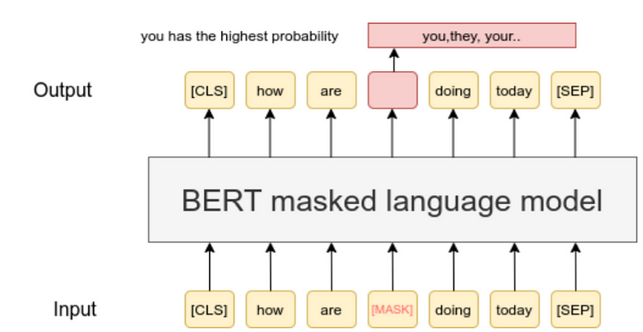
Masked Language Model (MLM)
Before BERT can work its magic on text, it needs to be prepared and structured in a way that it can understand. In this chapter, we’ll explore the crucial steps of preprocessing text for BERT, including tokenization, input formatting, and the Masked Language Model (MLM) objective.
Tokenization: Breaking Text into Meaningful Chunks
Imagine you’re teaching BERT to read a book. You wouldn’t hand in the entire book at once; you’d break it into sentences and paragraphs. Similarly, BERT needs text to be broken down into smaller units called tokens. But here’s the twist: BERT uses WordPiece tokenization. It splits words into smaller pieces, like turning “running” into “run” and “ning.” This helps handle tricky words and ensures that BERT doesn’t get lost in unfamiliar words.
Example: Original Text: “ChatGPT is fascinating.” WordPiece Tokens: [“Chat”, “##G”, “##PT”, “is”, “fascinating”, “.”]
Input Formatting: Giving BERT the Context
BERT loves context, and we need to serve it to him on a platter. To do that, we format the tokens in a way that BERT understands. We add special tokens like [CLS] (stands for classification) at the beginning and [SEP] (stands for separation) between sentences. As Shown in the Figure (Machine Language Model). We also assign segment embeddings to tell BERT which tokens belong to which sentence.
Example: Original Text: “ChatGPT is fascinating.” Formatted Tokens: [“[CLS]”, “Chat”, “##G”, “##PT”, “is”, “fascinating”, “.”, “[SEP]”]
Masked Language Model (MLM) Objective: Teaching BERT Context
BERT’s secret sauce lies in its ability to understand the bidirectional context. During its training, some words are masked (replaced with [MASK]) in sentences, and BERT learns to predict those words from their context. This helps BERT grasp how words relate to each other, both before and after. As Shown in the Figure (Machine Language Model)
Example: Original Sentence: “The cat is on the mat.” Masked Sentence: “The [MASK] is on the mat.”
Code Snippet: Tokenization with Hugging Face Transformers
from transformers import BertTokenizer
tokenizer = BertTokenizer.from_pretrained('bert-base-uncased')
text = "BERT preprocessing is essential."
tokens = tokenizer.tokenize(text)
print(tokens)
This code uses the Hugging Face Transformers library to tokenize text using the BERT tokenizer.
In the next chapter, we’ll delve into the fascinating world of fine-tuning BERT for specific tasks and explore how its attention mechanism makes it a language-understanding champ. Stick around to learn more!
Chapter 3: Fine-Tuning BERT for Specific Tasks
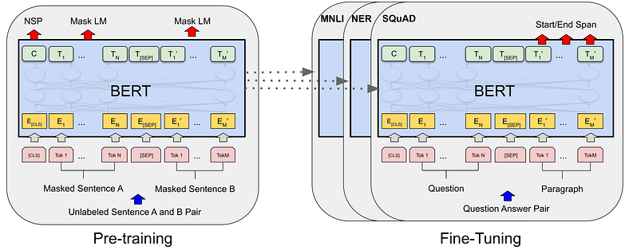
Fine-Tuning BERT
After understanding how BERT works, it’s time to put its magic to practical use. In this chapter, we’ll explore how to fine-tune BERT for specific language tasks. This involves adapting the pre-trained BERT model to perform tasks like text classification. Let’s dive in!
BERT’s Architecture Variations: Finding the Right Fit
BERT comes in different flavors like BERT-base, BERT-large, and more. The variations have varying model sizes and complexities. The choice depends on your task’s requirements and the resources you have. Larger models might perform better, but they also require more computational power.
Transfer Learning in NLP: Building on Pretrained Knowledge
Imagine BERT as a language expert who has already read a ton of text. Instead of teaching it everything from scratch, we fine-tune it on specific tasks. This is the magic of transfer learning — leveraging BERT’s pre-existing knowledge and tailoring it for a particular task. It’s like having a tutor who knows a lot and just needs some guidance for a specific subject.
Downstream Tasks and Fine-Tuning: Adapting BERT’s Knowledge
The tasks we fine-tune BERT for are called “downstream tasks.” Examples include sentiment analysis, named entity recognition, and more. Fine-tuning involves updating BERT’s weights using task-specific data. This helps BERT specialize in these tasks without starting from scratch.
Example: Text Classification with BERT
from transformers import BertForSequenceClassification, BertTokenizer
import torch
tokenizer = BertTokenizer.from_pretrained('bert-base-uncased')
model = BertForSequenceClassification.from_pretrained('bert-base-uncased')
text = "This movie was amazing!"
inputs = tokenizer(text, return_tensors='pt')
outputs = model(**inputs)
predictions = torch.argmax(outputs.logits, dim=1)
print(predictions)
This code demonstrates using a pre-trained BERT model for text classification using Hugging Face Transformers.
In this snippet, we load a pre-trained BERT model designed for text classification. We tokenize the input text, pass it through the model, and get predictions.
Fine-tuning BERT for specific tasks allows it to shine in real-world applications. In the next chapter, we’ll unravel the inner workings of BERT’s attention mechanism, which is key to its contextual understanding. Stay tuned to uncover more!
Chapter 4: BERT’s Attention Mechanism
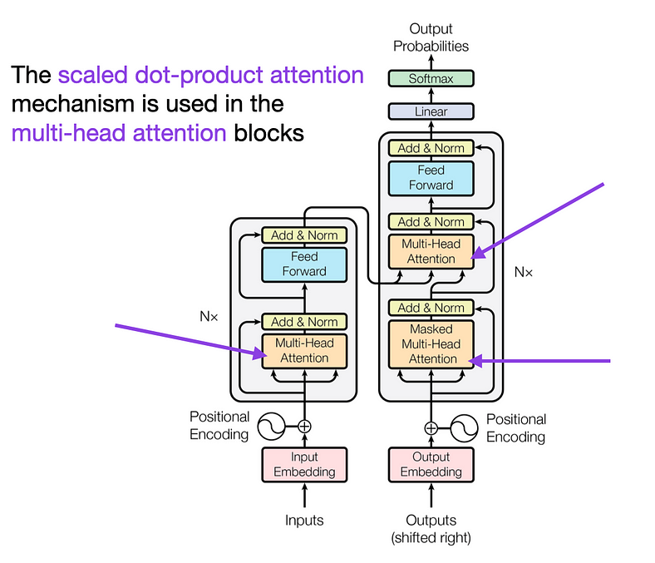
Self-Attention Mechanism
Now that we’ve seen how to apply BERT to tasks, let’s dig deeper into what makes BERT so powerful — its attention mechanism. In this chapter, we’ll explore self-attention, multi-head attention, and how BERT’s attention mechanism allows it to grasp the context of language.
Self-Attention: BERT’s Superpower
Imagine reading a book and highlighting the words that seem most important to you. Self-attention is like that, but for BERT. It looks at each word in a sentence and decides how much attention it should give to other words based on their importance. This way, BERT can focus on relevant words, even if they’re far apart in the sentence.
Multi-Head Attention: The Teamwork Trick
BERT doesn’t rely on just one perspective; it uses multiple “heads” of attention. Think of these heads as different experts focusing on various aspects of the sentence. This multi-head approach helps BERT capture different relationships between words, making its understanding richer and more accurate.
Attention in BERT: The Contextual Magic
BERT’s attention isn’t limited to just the words before or after a word. It considers both directions! When BERT reads a word, it’s not alone; it’s aware of its neighbors. This way, BERT generates embeddings that consider the entire context of a word. It’s like understanding a joke not just by the punchline but also by the setup.
Code Snippet: Visualizing Attention Weights
import torch
from transformers import BertModel, BertTokenizer
tokenizer = BertTokenizer.from_pretrained('bert-base-uncased')
model = BertModel.from_pretrained('bert-base-uncased')
text = "BERT's attention mechanism is fascinating."
inputs = tokenizer(text, return_tensors='pt', padding=True, truncation=True)
outputs = model(**inputs, output_attentions=True)
attention_weights = outputs.attentions
print(attention_weights)
In this code, we visualize BERT’s attention weights using Hugging Face Transformers. These weights show how much attention BERT pays to different words in the sentence.
BERT’s attention mechanism is like a spotlight, helping it focus on what matters most in a sentence. In the next chapter, we’ll delve into BERT’s training process and how it becomes the language maestro it is. Stay tuned for more insights!
Chapter 5: BERT’s Training Process
Understanding how BERT learns is key to appreciating its capabilities. In this chapter, we’ll uncover the intricacies of BERT’s training process, including its pretraining phase, the Masked Language Model (MLM) objective, and the Next Sentence Prediction (NSP) objective.
Pretraining Phase: The Knowledge Foundation
BERT’s journey begins with pretraining, where it learns from an enormous amount of text data. Imagine showing BERT millions of sentences and letting it predict missing words. This exercise helps BERT build a solid understanding of language patterns and relationships.
Masked Language Model (MLM) Objective: The Fill-in-the-Blanks Game
During pretraining, BERT is given sentences with some words masked (hidden). It then tries to predict those masked words based on the surrounding context. This is like a language version of the fill-in-the-blanks game. By guessing the missing words, BERT learns how words relate to each other, achieving its contextual brilliance.
Next Sentence Prediction (NSP) Objective: Grasping Sentence Flow
BERT doesn’t just understand words; it grasps the flow of sentences. In the NSP objective, BERT is trained to predict if one sentence follows another in a text pair. This helps BERT comprehend the logical connections between sentences, making it a master at understanding paragraphs and longer texts.
Example: Pretraining and MLM
from transformers import BertForMaskedLM, BertTokenizer
import torch
tokenizer = BertTokenizer.from_pretrained('bert-base-uncased')
model = BertForMaskedLM.from_pretrained('bert-base-uncased')
text = "BERT is a powerful language model."
inputs = tokenizer(text, return_tensors='pt', padding=True, truncation=True, add_special_tokens=True)
outputs = model(**inputs, labels=inputs['input_ids'])
loss = outputs.loss
print(loss)
This code demonstrates pretraining BERT’s Masked Language Model (MLM). The model predicts masked words while being trained to minimize the prediction error.
BERT’s training process is like teaching it the rules of language through a mix of fill-in-the-blanks and sentence-pair understanding exercises. In the next chapter, we’ll dive into BERT’s embeddings and how they contribute to its language prowess. Keep learning!
Chapter 6: BERT Embeddings
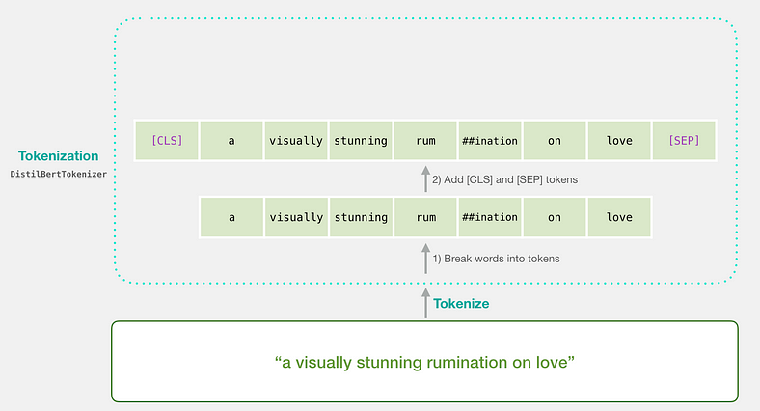
BERT Word Embeddings
BERT’s power lies in its ability to represent words in a way that captures their meaning within a specific context. In this chapter, we’ll unravel BERT’s embeddings, including its contextual word embeddings, WordPiece tokenization, and positional encodings.
Word Embeddings vs. Contextual Word Embeddings
Think of word embeddings as code words for words. BERT takes this a step further with contextual word embeddings. Instead of just having one code word for each word, BERT creates different embeddings for the same word based on its context in a sentence. This way, each word’s representation is more nuanced and informed by the surrounding words.
WordPiece Tokenization: Handling Complex Vocabulary
BERT’s vocabulary is like a puzzle made of smaller pieces called subwords. It uses WordPiece tokenization to break down words into these subwords. This is particularly useful for handling long and complex words, as well as for tackling words it hasn’t seen before.
Positional Encodings: Navigating Sentence Structure
Since BERT reads words in a bidirectional manner, it needs to know the position of each word in a sentence. Positional encodings are added to the embeddings to give BERT this spatial awareness. This way, BERT knows not just what words mean, but also where they belong in a sentence.
Code Snippet: Extracting Word Embeddings with Hugging Face Transformers
from transformers import BertTokenizer, BertModel
import torch
tokenizer = BertTokenizer.from_pretrained('bert-base-uncased')
model = BertModel.from_pretrained('bert-base-uncased')
text = "BERT embeddings are fascinating."
inputs = tokenizer(text, return_tensors='pt', padding=True, truncation=True, add_special_tokens=True)
outputs = model(**inputs)
word_embeddings = outputs.last_hidden_state
print(word_embeddings)
This code shows how to extract word embeddings using Hugging Face Transformers. The model generates contextual embeddings for each word in the input text.
BERT’s embeddings are like a language playground where words get their unique context-based identities. In the next chapter, we’ll explore advanced techniques for fine-tuning BERT and adapting it to various tasks. Keep learning and experimenting!
Key Features of BERT
- Encoder-Only Architecture: BERT consists solely of Transformer encoders, which process input data bidirectionally, meaning it looks at the entire context of a word in a sentence rather than just the preceding or following words. This helps capture the meaning of a word based on its context.
- Pre-training and Fine-tuning: BERT is pre-trained on a large corpus of text using two main tasks:
  - Masked Language Modeling (MLM): Randomly masks some of the words in the input sentence and trains the model to predict those masked words based on their context.
  - Next Sentence Prediction (NSP): Given a pair of sentences, the model learns to predict if the second sentence follows the first in the original text.
- Contextualized Word Representations: Unlike traditional word embeddings (like Word2Vec or GloVe), which produce a single vector for each word regardless of context, BERT generates different embeddings for a word depending on its surrounding words. This allows it to understand nuances and meanings in context.
- Versatile Applications: After pre-training, BERT can be fine-tuned for various downstream tasks, such as:
  - Sentiment analysis
  - Named entity recognition (NER)
  - Question answering
  - Text classification
Comparison with Other Transformer Models
- GPT: Unlike BERT, models like GPT (Generative Pre-trained Transformer) use only the decoder part of the Transformer architecture and are designed primarily for text generation tasks.
- T5 and BART: These models utilize both encoders and decoders and can handle various tasks like summarization and translation.
BERT has significantly influenced the field of natural language processing (NLP) due to its effectiveness in understanding and generating human language based on context.
Chapter 7: BERT’s Advanced Techniques
As you become proficient with BERT, it’s time to explore advanced techniques that maximize its potential. In this chapter, we’ll delve into strategies for fine-tuning, handling out-of-vocabulary words, domain adaptation, and even knowledge distillation from BERT.
Fine-Tuning Strategies: Mastering Adaptation
Fine-tuning BERT requires careful consideration. You can fine-tune not only the final classification layer but also intermediate layers. This enables BERT to adapt more effectively to your specific task. Experiment with different layers and learning rates to find the best combination.
Handling Out-of-Vocabulary (OOV) Words: Taming the Unknown
BERT’s vocabulary isn’t infinite, so it can encounter words it doesn’t recognize. When handling OOV words, you can split them into subwords using WordPiece tokenization. Alternatively, you can replace them with a special token, like “[UNK]” for unknown. Balancing OOV strategies is a skill that improves with practice.
Domain Adaptation with BERT: Making BERT Yours
BERT, though powerful, may not perform optimally in every domain. Domain adaptation involves fine-tuning BERT on domain-specific data. By exposing BERT to domain-specific text, it learns to understand the unique language patterns of that domain. This can greatly enhance its performance for specialized tasks.
Knowledge Distillation from BERT: Passing on the Wisdom
Knowledge distillation involves training a smaller model (student) to mimic the behavior of a larger, pre-trained model (teacher) like BERT. This compact model learns not just the teacher’s predictions but also its confidence and reasoning. This approach is particularly useful when deploying BERT on resource-constrained devices.
Code Snippet: Fine-Tuning Intermediate Layers with Hugging Face Transformers
from transformers import BertForSequenceClassification, BertTokenizer
import torch
tokenizer = BertTokenizer.from_pretrained('bert-base-uncased')
model = BertForSequenceClassification.from_pretrained('bert-base-uncased')
text = "Advanced fine-tuning with BERT."
inputs = tokenizer(text, return_tensors='pt', padding=True, truncation=True)
outputs = model(**inputs, output_hidden_states=True)
intermediate_layer = outputs.hidden_states[6] # 7th layer
print(intermediate_layer)
This code illustrates fine-tuning BERT’s intermediate layers using Hugging Face Transformers. Extracting intermediate layers can help fine-tune BERT more effectively for specific tasks.
As you explore these advanced techniques, you’re on your way to mastering BERT’s adaptability and potential. In the next chapter, we’ll dive into recent developments and variants of BERT that have further elevated the field of NLP. Stay curious and keep innovating!
Chapter 8: Recent Developments and Variants
As the field of Natural Language Processing (NLP) evolves, so does BERT. In this chapter, we’ll explore recent developments and variants that have taken BERT’s capabilities even further, including RoBERTa, ALBERT, DistilBERT, and ELECTRA.
RoBERTa: Beyond BERT’s Basics
RoBERTa is like BERT’s clever sibling. It’s trained with a more thorough recipe, involving larger batches, more data, and more training steps. This enhanced training regimen results in even better language understanding and performance across various tasks.
ALBERT: A Lite BERT
ALBERT stands for “A Lite BERT.” It’s designed to be efficient, using parameter-sharing techniques to reduce memory consumption. Despite its smaller size, ALBERT maintains BERT’s power and can be particularly useful when resources are limited.
DistilBERT: Compact Yet Knowledgeable
DistilBERT is a distilled version of BERT. It’s trained to mimic BERT’s behavior but with fewer parameters. This makes DistilBERT lighter and faster while still retaining a good portion of BERT’s performance. It’s a great choice for applications where speed and efficiency matter.
ELECTRA: Efficiently Learning from BERT
ELECTRA introduces an interesting twist to training. Instead of predicting masked words, ELECTRA trains by detecting whether a replaced word is real or artificially generated. This efficient method makes ELECTRA a promising approach for training large models without the full computational cost.
Code Snippet: Using RoBERTa with Hugging Face Transformers
from transformers import RobertaTokenizer, RobertaModel
import torch
tokenizer = RobertaTokenizer.from_pretrained('roberta-base')
model = RobertaModel.from_pretrained('roberta-base')
text = "RoBERTa is an advanced variant of BERT."
inputs = tokenizer(text, return_tensors='pt', padding=True, truncation=True)
outputs = model(**inputs)
embeddings = outputs.last_hidden_state
print(embeddings)
This code demonstrates using RoBERTa, a variant of BERT, for generating contextual embeddings using Hugging Face Transformers.
These recent developments and variants show how BERT’s impact has rippled through the NLP landscape, inspiring new and enhanced models. In the next chapter, we’ll explore how BERT can be used for sequence-to-sequence tasks like text summarization and language translation. Stay tuned for more exciting applications of BERT!
Chapter 9: BERT for Sequence-to-Sequence Tasks
In this chapter, we’ll explore how BERT, originally designed for understanding individual sentences, can be adapted for more complex tasks like sequence-to-sequence applications. We’ll dive into text summarization, language translation, and even its potential in conversational AI.
BERT for Text Summarization: Condensing Information
Text summarization involves distilling the essence of a longer text into a shorter version while retaining its core meaning. Although BERT isn’t specifically built for this, it can still be used effectively by feeding the original text and generating a concise summary using the contextual understanding it offers.
BERT for Language Translation: Bridging Language Gaps
Language translation involves converting text from one language to another. While BERT isn’t a translation model per se, its contextual embeddings can enhance the quality of translation models. By understanding the context of words, BERT can aid in preserving the nuances of the original text during translation.
BERT in Conversational AI: Understanding Dialogue
Conversational AI requires understanding not just individual sentences but also the flow of dialogue. BERT’s bidirectional context comes in handy here. It can analyze and generate responses that are contextually coherent, making it a valuable tool for creating more engaging chatbots and virtual assistants.
Code Snippet: Text Summarization using BERT with Hugging Face Transformers
from transformers import BertTokenizer, BertForSequenceClassification
import torch
tokenizer = BertTokenizer.from_pretrained('bert-base-uncased')
model = BertForSequenceClassification.from_pretrained('bert-base-uncased')
original_text = "Long text for summarization..."
inputs = tokenizer(original_text, return_tensors='pt', padding=True, truncation=True)
summary_logits = model(**inputs).logits
summary = tokenizer.decode(torch.argmax(summary_logits, dim=1))
print("Summary:", summary)
This code demonstrates using BERT for text summarization using Hugging Face Transformers. The model generates a summary by predicting the most relevant parts of the input text.
As you explore BERT’s capabilities in sequence-to-sequence tasks, you’ll discover its adaptability to various applications beyond its original design. In the next chapter, we’ll tackle common challenges in using BERT and how to address them effectively. Stay tuned for insights on overcoming obstacles in BERT-powered projects!
Chapter 10: Common Challenges and Mitigations
As powerful as BERT is, it’s not without its challenges. In this chapter, we’ll dive into some common issues you might encounter while working with BERT and provide strategies to overcome them. From handling long texts to managing computational resources, we’ve got you covered.
Challenge 1: Dealing with Long Texts
BERT has a maximum token limit for input, and long texts can get cut off. To mitigate this, you can split the text into manageable chunks and process them separately. You’ll need to carefully manage the context between these chunks to ensure meaningful results.
Code Snippet: Handling Long Texts with BERT
max_seq_length = 512 # Max token limit for BERT
text = "Long text to be handled..."
text_chunks = [text[i:i + max_seq_length] for i in range(0, len(text), max_seq_length)]
for chunk in text_chunks:
inputs = tokenizer(chunk, return_tensors='pt', padding=True, truncation=True)
outputs = model(**inputs)
# Process outputs for each chunk
Challenge 2: Resource Intensive Computation
BERT models, especially the larger ones, can be computationally demanding. To address this, you can use techniques like mixed-precision training, which reduces memory consumption and speeds up training. Additionally, you might consider using smaller models or cloud resources for heavy tasks.
Code Snippet: Mixed-Precision Training with BERT
from torch.cuda.amp import autocast, GradScaler
scaler = GradScaler()
with autocast():
inputs = tokenizer(text, return_tensors='pt', padding=True, truncation=True)
outputs = model(**inputs)
loss = outputs.loss
scaler.scale(loss).backward()
scaler.step(optimizer)
scaler.update()
Challenge 3: Domain Adaptation
While BERT is versatile, it might not perform optimally in certain domains. To address this, fine-tune BERT on domain-specific data. By exposing it to text from the target domain, BERT will learn to understand the nuances and terminology specific to that field.
Code Snippet: Domain Adaptation with BERT
domain_data = load_domain_specific_data() # Load domain-specific dataset
domain_model = BertForSequenceClassification.from_pretrained('bert-base-uncased')
train_domain(domain_model, domain_data)
Navigating these challenges ensures that you can harness BERT’s capabilities effectively, regardless of the complexities you encounter. In the final chapter, we’ll reflect on the journey and explore potential future developments in the world of language models. Keep pushing the boundaries of what you can achieve with BERT!
Chapter 11: Future Directions in NLP with BERT
As we conclude our exploration of BERT, let’s gaze into the future and glimpse the exciting directions that Natural Language Processing (NLP) is headed. From multilingual understanding to cross-modal learning, here are some trends that promise to shape the NLP landscape.
Multilingual and Cross-Lingual Understanding
BERT’s power isn’t limited to English. Researchers are expanding their reach to multiple languages. By training BERT in a diverse range of languages, we can enhance its capability to understand and generate text in different tongues.
Code Snippet: Multilingual BERT with Hugging Face Transformers
from transformers import BertTokenizer, BertModel
import torch
tokenizer = BertTokenizer.from_pretrained('bert-base-multilingual-cased')
model = BertModel.from_pretrained('bert-base-multilingual-cased')
text = "BERT understands multiple languages!"
inputs = tokenizer(text, return_tensors='pt', padding=True, truncation=True)
outputs = model(**inputs)
embeddings = outputs.last_hidden_state
print(embeddings)
Cross-Modal Learning: Beyond Text
BERT’s contextual understanding isn’t limited to text. Emerging research is exploring its application to other forms of data, like images and audio. This cross-modal learning holds the promise of deeper insights by connecting information from multiple sources.
Lifelong Learning: Adapting to Change
BERT’s current training involves a static dataset, but future NLP models are likely to adapt to evolving language trends. Lifelong learning models continuously update their knowledge, ensuring that they remain relevant as languages and contexts evolve.
Code Snippet: Lifelong Learning with BERT
from transformers import BertForSequenceClassification, BertTokenizer
import torch
tokenizer = BertTokenizer.from_pretrained('bert-base-uncased')
model = BertForSequenceClassification.from_pretrained('bert-base-uncased')
new_data = load_latest_data() # Load updated dataset
for epoch in range(epochs):
train_lifelong(model, new_data)
Quantum Leap in Chatbots: More Human-Like Conversations
Advancements in NLP models like GPT-3 have shown us the potential for more natural conversations with AI. The future holds even more lifelike interactions as BERT’s understanding of context and dialogue continues to improve.
The future of NLP is a tapestry of innovation and possibility. As you embrace these trends, remember that BERT’s legacy as a cornerstone of language understanding will continue to shape the way we interact with technology and each other. Keep your curiosity alive and explore the realms that lie ahead!
Chapter 12: Implementing BERT with Hugging Face Transformers Library
Now that you’ve gained a solid understanding of BERT, it’s time to put your knowledge into action. In this chapter, we’ll dive into practical implementation using the Hugging Face Transformers library, a powerful toolkit for working with BERT and other transformer-based models.
Installing Hugging Face Transformers
To get started, you’ll need to install the Hugging Face Transformers library. Open your terminal or command prompt and use the following command:
pip install transformers
Loading a Pretrained BERT Model
Hugging Face Transformers makes it easy to load pre-trained BERT models. You can choose from various model sizes and configurations. Let’s load a basic BERT model for text classification:
from transformers import BertForSequenceClassification, BertTokenizer
model = BertForSequenceClassification.from_pretrained('bert-base-uncased')
tokenizer = BertTokenizer.from_pretrained('bert-base-uncased')
Tokenizing and Encoding Text
BERT processes text in tokenized form. You’ll need to tokenize your text using the tokenizer and encode it for the model:
text = "BERT is amazing!"
inputs = tokenizer(text, return_tensors='pt', padding=True, truncation=True)
Making Predictions
Once you’ve encoded your text, you can use the model to make predictions. For example, let’s perform sentiment analysis:
outputs = model(**inputs)
predicted_class = torch.argmax(outputs.logits).item()
print("Predicted Sentiment Class:", predicted_class)
Fine-Tuning BERT
Fine-tuning BERT for specific tasks involves loading a pre-trained model, adapting it to your task, and training it on your dataset. Here’s a simplified example for text classification:
from transformers import BertForSequenceClassification, BertTokenizer, AdamW
import torch
model = BertForSequenceClassification.from_pretrained('bert-base-uncased')
tokenizer = BertTokenizer.from_pretrained('bert-base-uncased')
text = "Sample text for training."
label = 1 # Assuming positive sentiment
inputs = tokenizer(text, return_tensors='pt', padding=True, truncation=True)
outputs = model(**inputs, labels=torch.tensor([label]))
loss = outputs.loss
optimizer = AdamW(model.parameters(), lr=1e-5)
loss.backward()
optimizer.step()
Exploring More Tasks and Models
The Hugging Face Transformers library provides a wide range of models and tasks to explore. You can fine-tune BERT for text classification, named entity recognition, question answering, and much more.
As you experiment with the Hugging Face Transformers library, you’ll find it to be an invaluable tool for implementing BERT and other transformer-based models in your projects. Enjoy the journey of turning theory into practical applications!
Conclusion: Unleashing the Power of BERT
In this blog post, we embarked on an enlightening journey through the transformative world of BERT — Bidirectional Encoder Representations from Transformers. From its inception to its practical implementation, we’ve traversed the landscape of BERT’s impact on Natural Language Processing (NLP) and beyond.
We delved into the challenges that come with utilizing BERT in real-world scenarios, uncovering strategies to tackle issues like handling long texts and managing computational resources. Our exploration of the Hugging Face Transformers library provided you with practical tools to harness the power of BERT in your own projects.
As we peered into the future, we caught a glimpse of the endless possibilities that lie ahead in NLP — from multilingual understanding to cross-modal learning and the continual evolution of language models.
Our journey doesn’t end here. BERT has set the stage for a new era of language understanding, bridging the gap between machines and human communication. As you venture into the dynamic world of AI, remember that BERT is a stepping stone to further innovations. Explore more, learn more, and create more, for the frontiers of technology are ever-expanding.
Thank you for joining us on this exploration of BERT. As you continue your learning journey, may your curiosity lead you to unravel even greater mysteries and contribute to the transformative landscape of AI and NLP.
RoBERTa, ALBERT, ELECTRA, XLNet, DistilBERT, SpanBERT, and BERTSUM are all variations of BERT, each with unique improvements for specific tasks in Natural Language Processing (NLP). Here's a simple summary:
RoBERTa
- Full name: "Robustly Optimized BERT Pretraining Approach."
- Key improvements: Trained longer on more data and bigger batches than BERT, uses dynamic masking (changing masked words during training), and skips Next Sentence Prediction (NSP).
- Outcome: Better results on language understanding tasks.
ALBERT
- Full name: "A Lite BERT."
- Key improvements: Reduces the number of parameters using two techniques—cross-layer parameter sharing (sharing weights across layers) and factorized embedding parameterization (separating input and hidden embeddings).
- Outcome: Faster and lighter than BERT while maintaining performance.
ELECTRA
- Full name: "Efficiently Learning an Encoder that Classifies Token Replacements Accurately."
- Key improvements: Uses a new training method called Replace Token Detection (RTD), where tokens are replaced rather than masked, and the model learns to identify which tokens are original.
- Outcome: More efficient training and better performance than BERT's original masking approach.
XLNet
- Key improvement: Combines BERT with a permutation-based training method, allowing it to consider word order more flexibly.
- Outcome: Better at understanding long-term word dependencies and performing tasks like question answering.
DistilBERT
- Key improvement: A smaller, faster version of BERT using knowledge distillation (a method where a large model teaches a smaller one).
- Outcome: Retains about 97% of BERT’s performance but is more efficient for use in mobile applications.
SpanBERT
- Key improvement: Focuses on predicting spans (contiguous sequences) of text rather than individual tokens, which makes it effective for tasks like question answering.
- Outcome: Outperforms BERT in scenarios where understanding larger pieces of context is important.
BERTSUM
- Key improvement: Fine-tuned specifically for text summarization, adapting BERT for both extractive and abstractive summarization.
- Outcome: Efficient at generating summaries from longer texts.
These BERT variants are tailored for different needs, such as speed, training efficiency, or performance on specific NLP tasks, making it easier to choose the right model based on the requirements of the task at hand.

